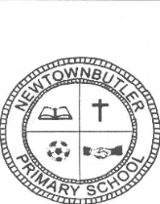**Newtownbutler Primary School**

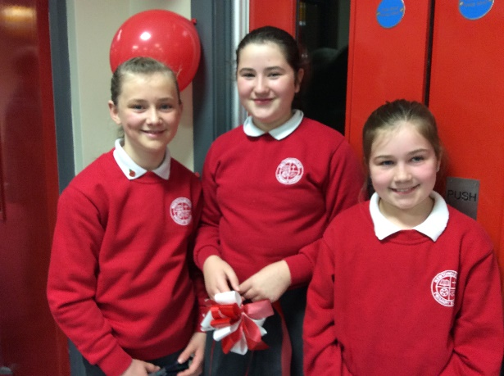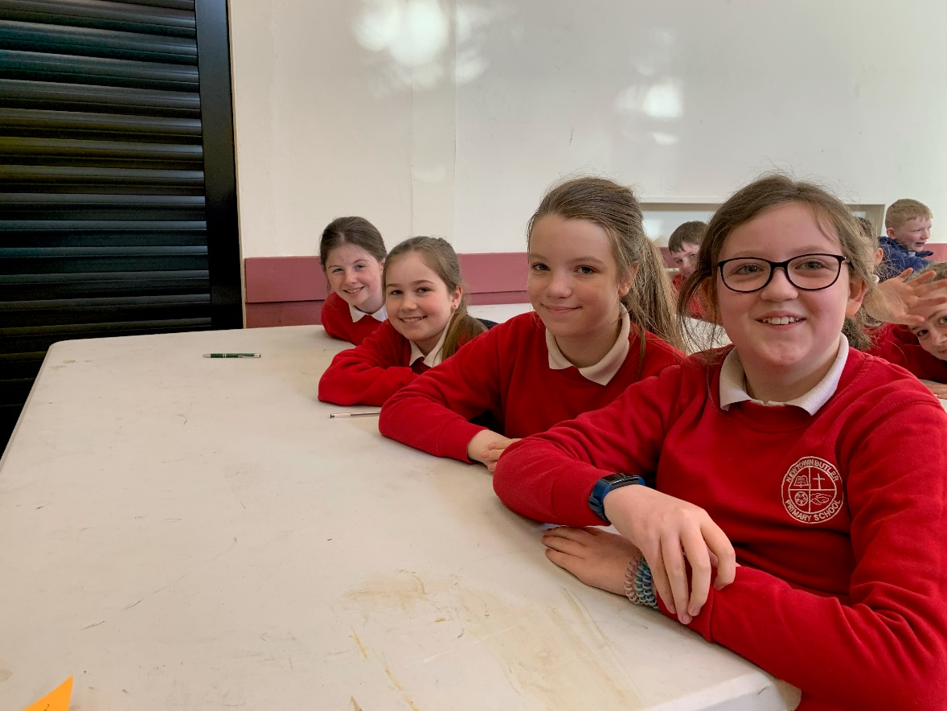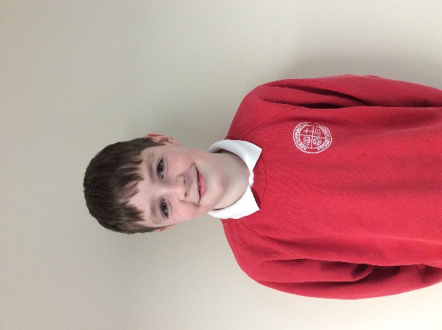

**Farewell Primary Seven!**

We wish you all the very best in your new school

From all the staff and pupils at Newtownbutler PS